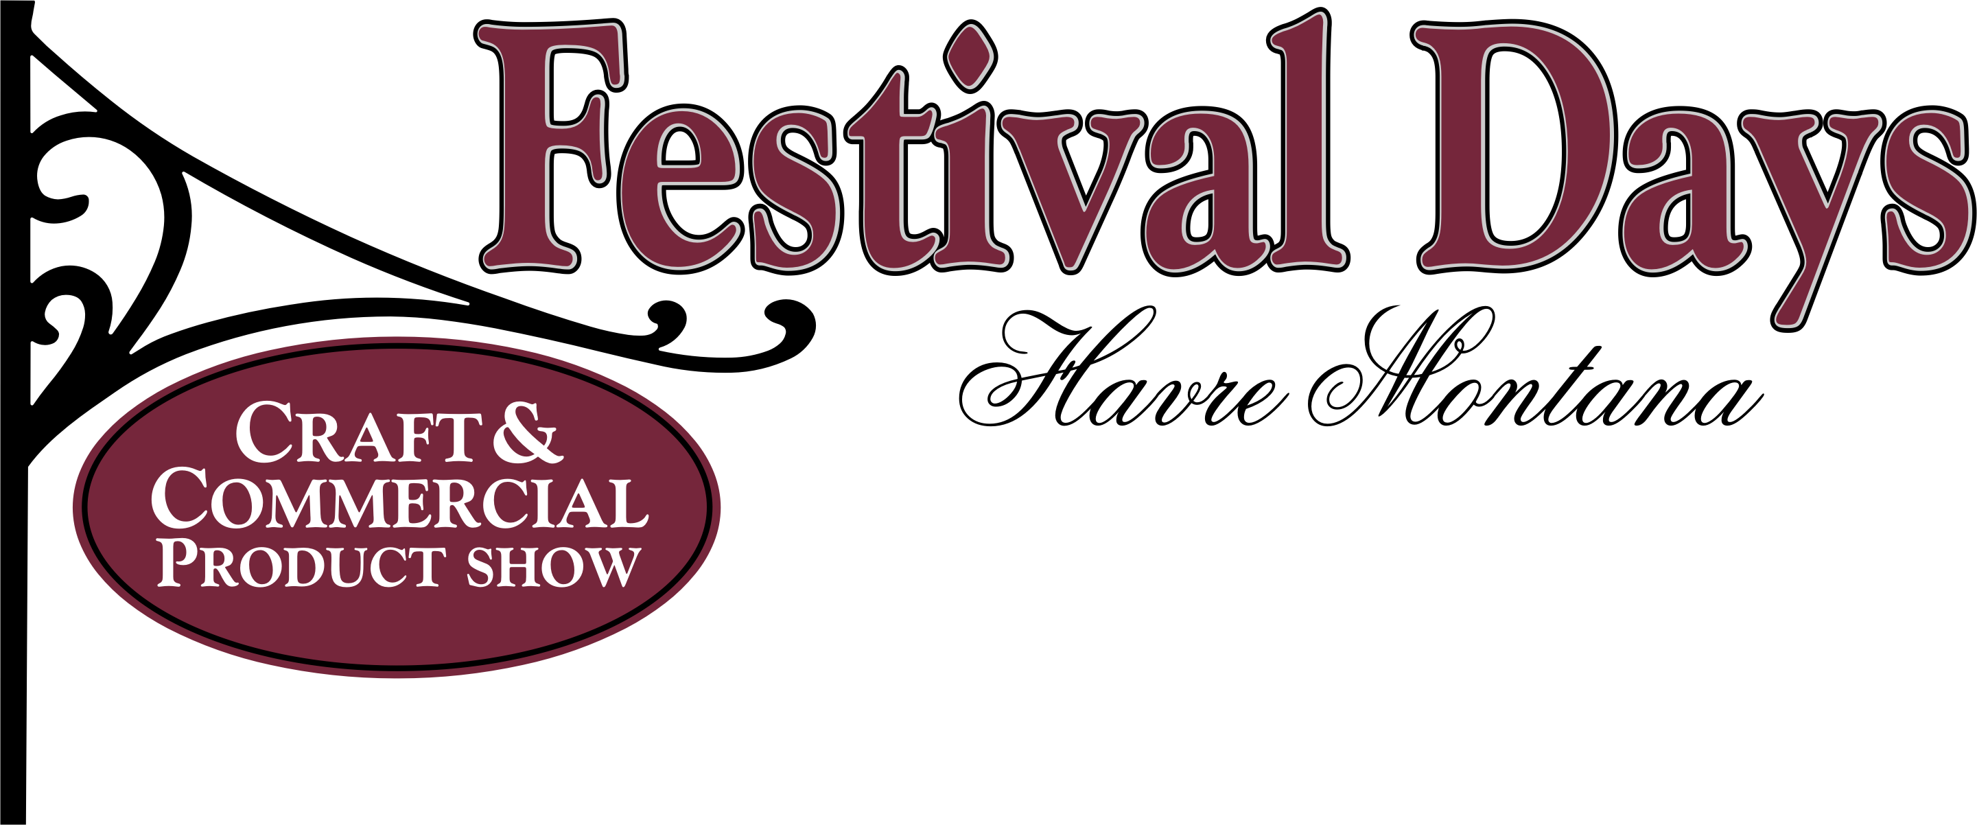
September 18, 2021
HAVRE FESTIVAL DAYS 39th ANNUAL
ARTS & CRAFT/COMMERCIAL PRODUCT SHOW
Our Show now has TWO locations.
This will allow for more vendors and a larger variety of items. You will have two options:
1. Indoors at the Holiday Village Mall. 1753 US HWY 2
Show Hours: Saturday, September 18th from 10am-5pm (1 day only)
2. Outside on the downtown streets of 3rd Ave (closed off)
Sat, Sept. 18th ONLY 8am-3pm.
Setup for both will be: Saturday, September 18, 2021 8:30am-10am (Mall) 7am-8am (Downtown)

Booth Size & Cost: Mall Approximately 10x10 $30.00/Each
Downtown 10x10 Saturday $30.00
Food Trucks $30.00

Registration is a commitment to have booth(s) set up for days selected. Booth(s) must be manned at all times.

Booth Set Up: *Crafters and Vendors are asked to provide their own tables and chairs.
* Canopies now allowed at mall (limited) with prior authorization.
*Due to fire regulations, please stay within your allotted space and do
not use aisle area or block doorways.*No smoking in booth, display area or building!!!
*No pets allowed in building!
*Exhibitors are responsible for keeping their spaces clean and disposing of trash in appropriate receptacle.
*Do not start to tear down your booth until 5pm (Mall), 3pm (Downtown). This is not good for the customers or other crafters.

Parking: No vehicles are allowed inside the mall building for unloading or loading.
Please remove vehicles immediately after unloading to allow other crafters easy access to unload. Vehicles must be out of loading area and booths filled by 10 A.M. so customers have access to crafts. Parking of vehicles will be in the eastern section of the Mall lot or in the back of the Mall. For Downtown, vehicles must be removed by 8A.M. you will be able to park on 2nd ST or 4th ST. No parking in the Atrium Parking Lot as there will be others set up there.

Deadlines: All entries must be postmarked by September 10, 2021.
Booth assignments are on a first come, first serve basis. Booth
location requests will be considered but not guaranteed!! This show sells out fast, so get your registration in early.
Confirmation will be emailed to you as soon as we receive payment.
Due to having two locations we will be allowing one vendor from each home-based company at each location. This will allow more people to participate and spread vendors out around town. Crafters and Vendors may not sell or lease their space to anyone without permission by the Havre Area Chamber of Commerce.

****For more information contact: Julea or Marla- (406) 265-4383

A list of motels is available upon request for out-of-town participants.

Watch for vendor postings on Havre Chamber Facebook page.

Havre Festival Days Arts & Crafts/Commercial Product Show Registration
September 18, 2021

( ) Holiday Village Mall ( ) Downtown 1-day ( ) Food Truck

Name ______________________________________________________________________

Address ____________________________________________________________________

City ___________________________ State ______________ Zip ______________________

Phone Number_______________________ email:____________________________________

Type of Craft/Product____________________________________ Booth Spaces (limit 2)_____

Show Registration For: Arts & Crafts _____ Vendor/Commercial Products ______

Electricity Needed (mall only, bring your own extension cord) _____ Tables Needed ( mall only $5 each)_______

Liability: “I agree to indemnify, defend, waive, release and hold the Havre Holiday Village Mall, Havre Area Chamber of Commerce, its Staff and Board of Directors and its Agents, harmless from any and all liability, claims and causes of action for injuries to person or property arising out of or related to this festival, specifically including, without limitation, injury of damage to booth and contents, merchandise, employees, contractors, guests, customers, invitees, all other third parties and any result from the use of any product purchased at the Arts & Crafts/Commercial Products Show.”

Mail Check & Registration To: Havre Area Chamber of Commerce
P.O. Box 308
Havre, MT 59501

**Booth fee is non-refundable (no exceptions)**
PLEASE INITIAL __________

I agree to the guidelines and policies by signing this registration.
I have been furnished with a copy of the rules of the Festival Days Arts & Crafts/Product Show. I understand that by violating these rules, I may be ineligible for re-admission to future shows.
Signed ____________________________________________ Date _______________________________

Office Use Only: Date rec’d_________Amt rec’d_________Downtown____ Mall______
First Come First Serve for Fountain Spaces at the mall - 8 Spaces Available

